# EXP5 Exception handling

**1 Experiment purpose**

Master the methods of exception handling in Java language, define exception classes, writes exception handling procedures to capture abnormal events.

**2 Development Environment**

1. Notepad++
2. JDK 1.8+

**3 Content and Steps**

**Problem 1:**

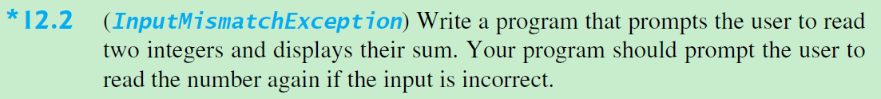

1. Implement a inputInt() method and catch the exception

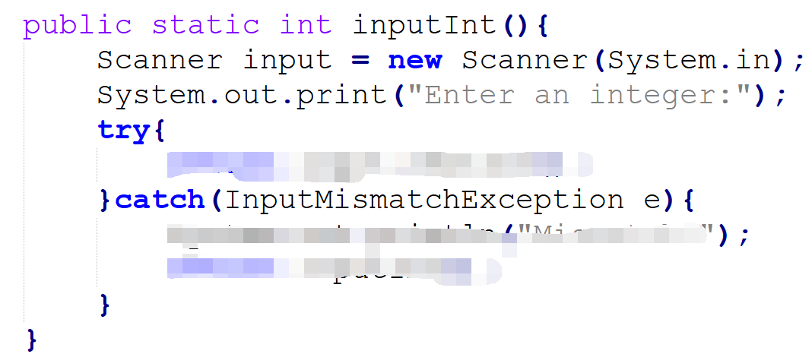

2. Test the input method.

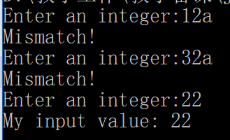

**Problem 2: 12.5**

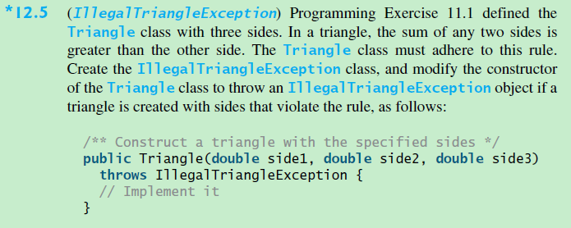

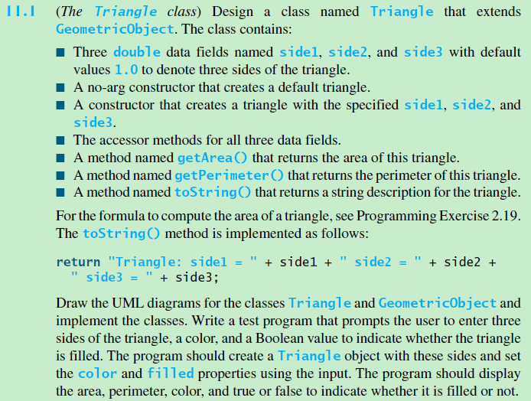

**Steps:**

1. Write a checked exception

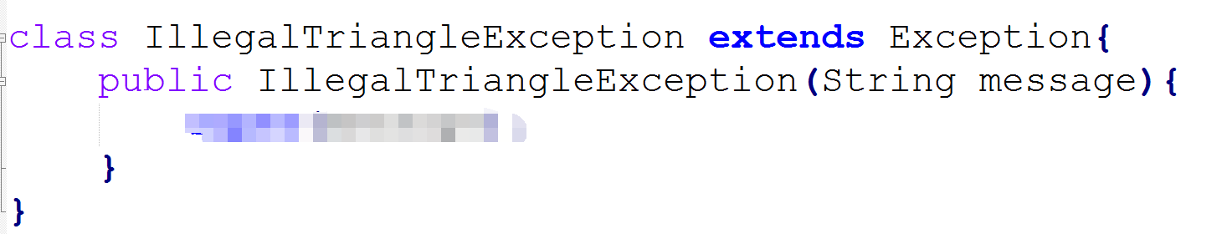

2. Write Triangle class and define the constructor

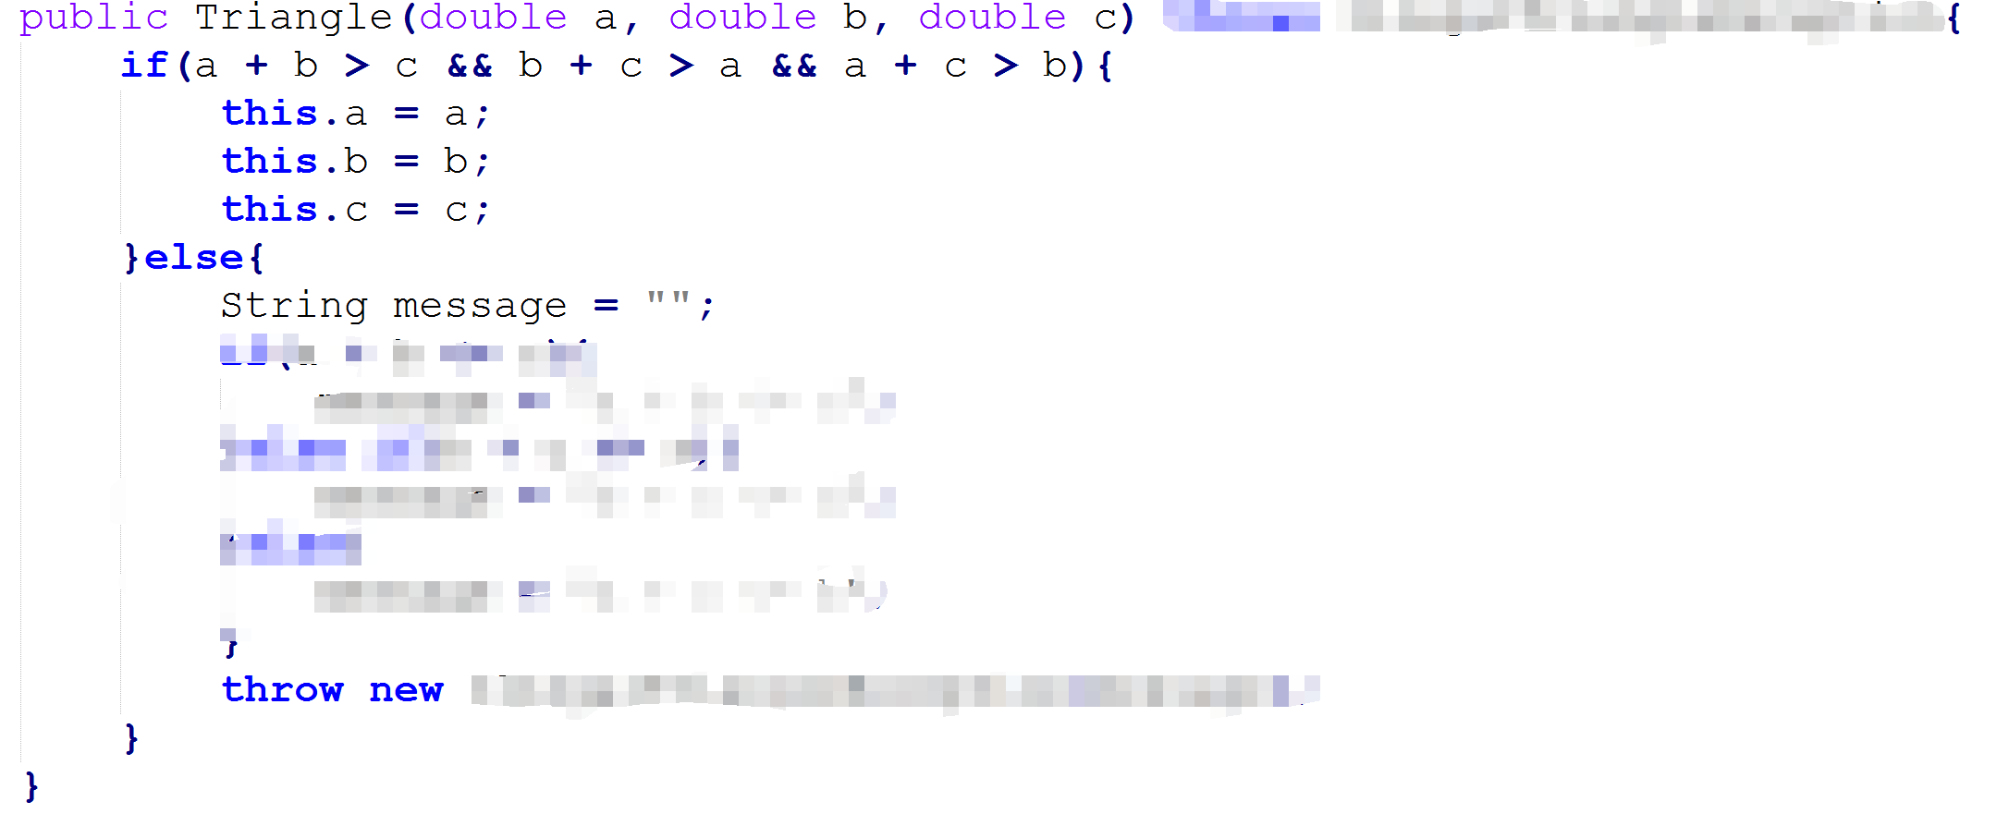

3. Write main method and catch the exceptions

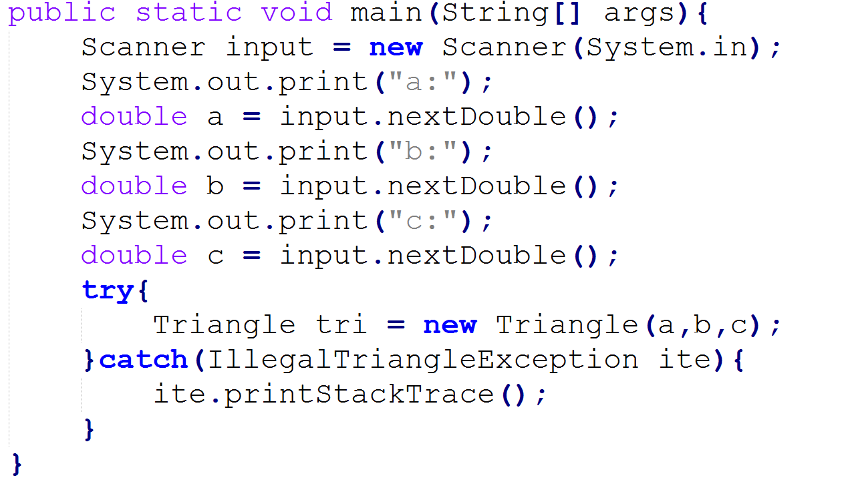

4. Test the program:

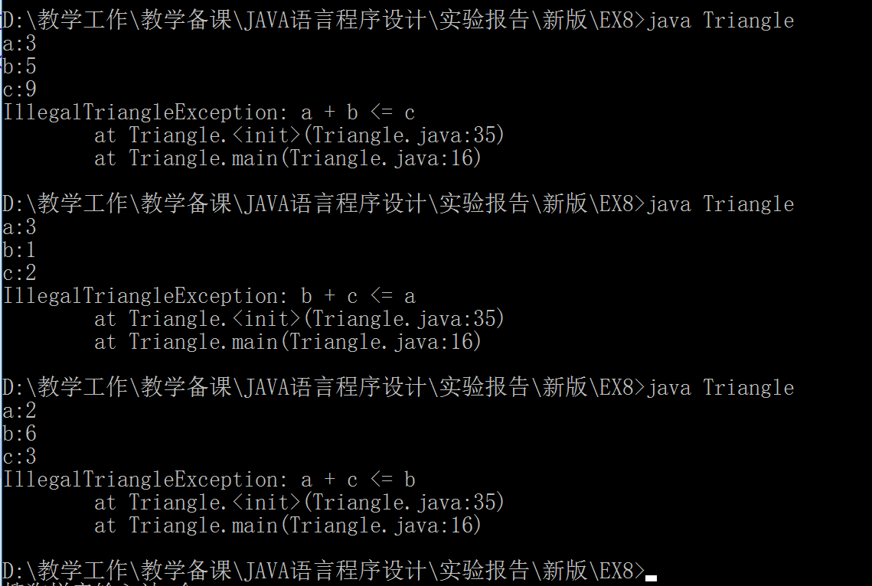

5. Rewrite the program and use unchecked exception (RuntimeException).